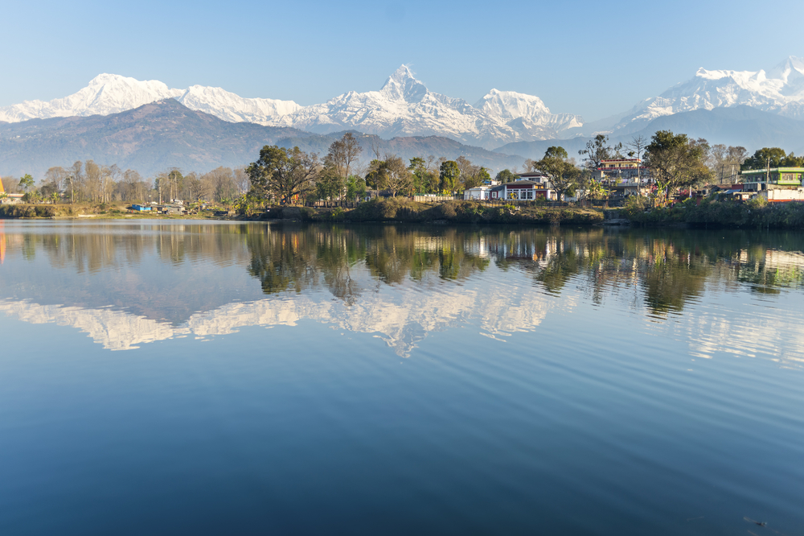
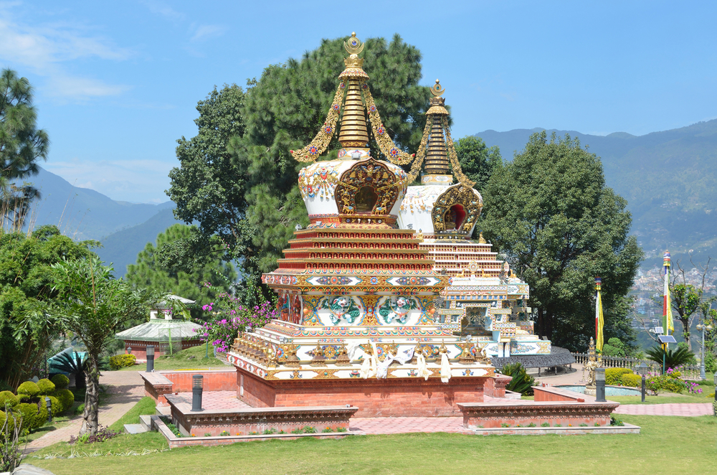

03 NIGHTS KATHMANDU

Day 01 Arrive Kathmandu

Morning transfer to airport to connect flight for Kathmandu You will be met by our representative at the arrivals lounge & escorted till your check in at Hotel..

Kathmandu is a small city founded around AD 723 as Manju-Patan. King Prithvi Narayan Shah was the man who made Kathmandu his capital in the 18th century and it never looked back after that. The opening of the country around 40 years back led to tremendous growth of tourism in the valley and the capital became a Mecca for trekkers, heaven for hippies, and a thriving cosmopolitan city.

Today Kathmandu is a fascinating old city where pagodas, narrow cobbled lanes, old carved windows, and stone shrines are backdrops to the drama of life that continues unhindered. Here the experiences are amazing, views fascinating, and the climate charming.

Overnight at hotel.

Day 02 In Kathmandu

Morning Sightseeing of Kathmandu Durbar Square (City) & Swyambhunath. Afternoon Patan Durbar Square.

KATHMANDU DURBAR SQUARE: It is the historic seat of royalty. The Durbar Square, with its old temples and places, epitomizes the religious and cultural life of the people. It is here that Kings of Nepal are crowned and their coronations solemnized. Interesting things to see here are; Taleju Temple built by King Mahendra Malla in 1549 A.D., Kal Bhairav, the God of destruction, Nautalle Durbar, Coronation Nasal Chowk, the Gaddi
Baithak, the statue of King Pratap Malla, the Big Bell, Big Drum and the Jagannath Temple. On the right-hand corner, large wooden lattice screen hides an enormous gilded face of Swet Bhairav. The screen is removed only during the Indra Jatra festival. There are also Numismatic and Tribhuvan Museum inside the Hanumandhoka Palace building.
SWAYAMBHUNATH: The history of the Valley, according to the legends, begins with Swayambhunath, or "the self existent". This is one of the world's most glorious Buddhist Stupa. It is around 2000 years old. The Stupa, which forms the main structure, is made of brick and clay supporting the lofty conical spire capped by a pinnacle of copper gilt. Painted on the four-sides of the spire base are the eyes of Lord Buddha. It is three kilometers west of Kathmandu City, and is situated on a hillock about 77m above the level of the Valley. This hill is a mosaic of small Chaityas and pagodas. Swayambhunath is, perhaps, the best place to observe the religious harmony of Buddhist and Hindu, in Nepal. It provides an excellent view of the Kathmandu Valley.

PATAN DURBAR SQUARE: This whole square is a cluster of fine pagoda temples and stone statues; it is at the same time the business hub of the city. At every step one comes across a piece of art or an image of a deity, testifying to the consummate skill of Patan's anonymous artists. The ancient palace of the Malla kings and the stone baths associated with various legends and episodes of history are especially interesting to visitors. The stone temple of Lord Krishna and the Royal Bath (Tushahity) with its intricate stone and bronze carvings are two other masterpieces in the same vicinity. This is the one of the UNESCO cultural heritage sites of Nepal.

Overnight at Hotel.

Day 03 In Kathmandu

Morning after breakfast visit Pashupatinath and Boudhnath. Afternoon Bhaktapur Durbar Square (Bhadgaon) & afternoon

PASHUPATINATH TEMPLE: 5 km away from Kathmandu, Pasupatinath Temple renowned for its superb architecture, its two-tiered golden roofs and silver doors, thousands of devotees converge here on an annual pilgrimage on the maha Shivratri (In February), the night of Lord Shiva. Entrance into the temple-precincts is permitted only for the Hindus but other can clearly see the temple and rituals beings performed inside from the eastern bank of the Bagmati river. Here Hindu people cremation their body.

BOUDDHANATH: Situated 7kms northwest of Kathmandu city, the Stupa of Bouddhanath contains the relics of Kashyap Buddha, one of the former Buddha’s. The stupa was much later renovated by the Lichchhavi rulers of the 8th century A.D. Bouddhanath is a very important and holy stupa to Buddhists, particularly to the Tibetan Buddhists. The lotus-born Guru, Guru Padmashambava had revealed its greatness and importance to the Tibetan King Trisondetsen (742-797 A.D.)
THE CITY OF BHAKTAPUR: Situated about 14 Km east Kathmandu city was founded in 9th Century by King Anand Dev. About 4000 feet above the sea level this city renowned for its pottery and weaving industry. DURBAR SQUARE: The main square of the city contains innumerable temples and other architectural showpieces such as lion gate, the golden gate, the statue of King Bhupatindra Malla. The palace of 55 windows, the big bell, the bell of barking dogs etc are other spots to be marked. PALACE OF 55 WINDOWS: Being built by King Yaksha Mall in 1427 A.D. and remodeled by King Bhupatindra Malla in 17th Century, the balcony and the windows are intricately carved. NYATAPOLA TEMPLE: This five storied Pagoda Style temple was built by King Bhupatindra Malla in 1708 A.D. well known for its massive structure and subtle workmanship.

Overnight at Hotel.

Day 04 Leave Kathmandu

Morning free.

Afternoon transfer to airport to connect flight for Delhi,. Upon arrival connect your flight to onward destination.

************************************************************************

